Small Business Application

To put in a client name select all (ctrl A) then f9Nash Tech Software Development

**Application Installation Guide**

**Version – Issue 0.1**

**10th April, 2019**

364 Cong Hoa Street

Tan Binh District

Ho Chi Minh City

Vietnam

Tel: (84) 8 3810 6200  
Fax: (84) 8 3810 6201

Email: nam.hoangvan@harveynash.vn

RECORD OF CHANGE

* A – Added, M – Modified, D - Deleted

|  |  |  |  |  |
| --- | --- | --- | --- | --- |
| **Date** | **Changed Items** | **\*A, M, D** | **Description** | **Version** |
| 10 April 2019 | All | A | Created | 0.2 |
|  |  |  |  |  |
|  |  |  |  |  |

SIGN OFF

|  |  |  |  |
| --- | --- | --- | --- |
|  | Name & Role | Date | Signature |
| **Originator** | Nam Hoang, TL | 10 April 2019 |  |
| **Reviewer/s** |  |  |  |
|  |  |  |  |
| **Approver/s** |  |  |  |

ASSOCIATED DOCUMENTS OR FILES

This document is associated with the following other documents or file:

|  |  |  |  |
| --- | --- | --- | --- |
| Title | Source | Issue Date | Version |
|  |  |  |  |
|  |  |  |  |

**CONFIDENTIALITY**

This document is distributed on a restricted basis, is commercial in confidence to the recipient, and may not be used for any purpose other than that associated with a Nash Tech project. The contents of this document may not be disclosed to any third parties without the expressed advance written authorisation of Nash Tech.

**CONSTRAINT**

This document is for persons who had basic knowledge of Front-end, Hybrid Mobile application (Cordova, Android and iOS).TABLE OF CONTENTS

1 Introduction 4

2 Required environment 4

2.1 Hardware 4

2.2 Software 5

3 The package structure 5

4 Create UserAccessControl database 6

5 Create clientdata (tenant) database 11

6 Create metadata database 14

7 Create main api from visual studio and configure 17

7.1 Open project with visual studio 17

7.2 Create package with visual studio 17

7.3 Configure Api 21

8 Create builder api package from visual studio and configure 22

8.1 Open project with visual studio 22

8.2 Create package with visual studio 22

8.3 Configure Api Uibuider 26

9 Create application pool 27

10 Host SBA_API on the IIS 28

11 Host UIBUILDER_API on the IIS 30

12 Host SBA web application on the IIS 32

13 Host UIBuilder web application on the IIS 34

14 Next 35

# Introduction

This document provides step by step to create package and deploy web applications, api and database for SBA project.

# Required environment

## Hardware

|  |  |  |
| --- | --- | --- |
| **Name** | **Description** | **Notes** |
| Server | **Processor:** Intel(R) Xeon(R) CPU E5-2640 0 @ 2.50GHz, 2500 Mhz, 2 Core(s), 2 Logical Processor(s) **Ram:** 5.00 GB  **HDD:** 100 GB |  |
| Application server | **Windows:** Windows Server 2012 Standard, CentOS 7  **IIS:** 8 (version 8.5.9600.16384)  **OS**: Windows Server 2008 R2 Enterprise 64bit  **MS SQL Server** : 64-bit SQL Server 2008 R2/2012 (64-bit Windows 2008 R2/2012) 2012 (version 11.0.2100.60)  **Microsoft .NET Framework**: NET Framework 4.5.2  **ASP.NET WEB API:** 2.0  **PowerShell** | This PC will be used to deploy database and application server |
| Macbook/iMac | **OS:** OS X Yosemite (version 10.10.5)  **Xcode:** 6.4 and above  **Android Studio**  **Android SDK:** 5.1.1  **Nodejs:** 2.7.4  **Cordova:** 5.1.1 | This PC will be used to build application for Android/iOS |

## Software

|  |  |
| --- | --- |
| Software | Version |
| Windows Server 2012 Standard, CentOS 7 | 64 bit |
| Internet Information Services (IIS) | 8 |
| Microsoft .NET Framework | 4.5.2 |
| Asp.net web api | 2.0 |
| Microsoft SQL Server | 64-bit SQL Server 2008 R2/2012 (64-bit Windows 2008 R2/2012) 2012 (version 11.0.2100.60) |
| Visual studio | 2012 64 bit |
| Powershell |  |

# The package structure

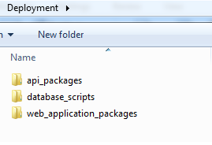

* Api_packages folder contain all web apis (main_api, uibuilder_api)  
  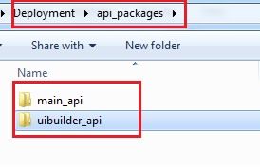
* Database_scripts folder contain all scripts to create database. You can also find these scripts on the svn with the path ./Development/SourceCode/database/SQL Scripts Deployment  
    
  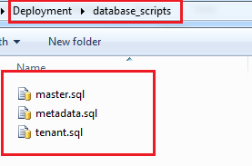
* Web_packages folder contain all web applications  
  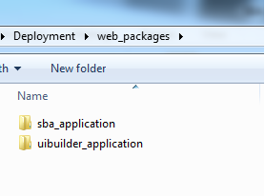

# Create UserAccessControl database

* Open your Sql Server then login  
  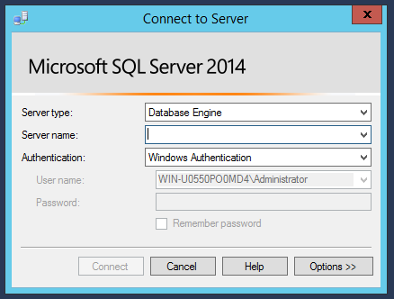
* Right click on database and choose New Database…  
  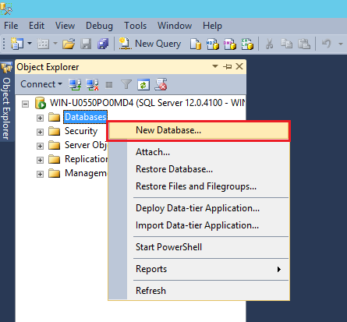
* Enter UserAccessControl then click OK button as the figure below  
  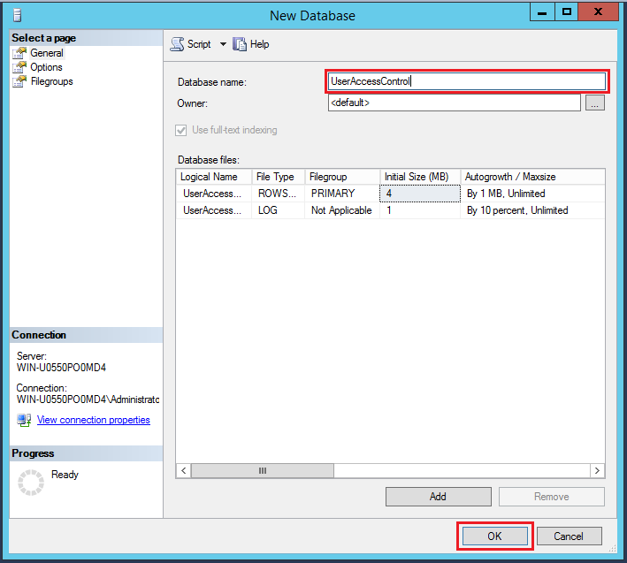
* After database is created, open script to create tables and insert data (Keyboard Shortcuts is Ctrl+O )  
  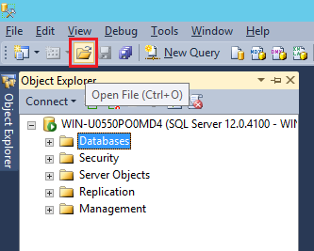
* Open master.sql file in the package that mentioned above  
  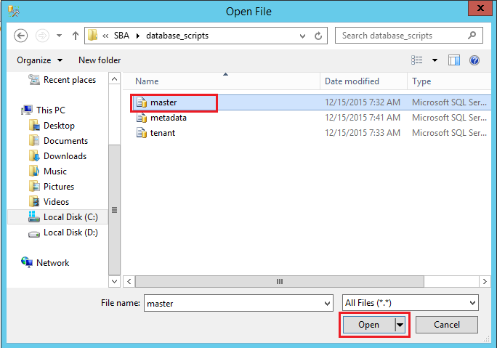
* Choose UserAccessControl database then click Execute (Keyboard Shortcuts is F5)  
  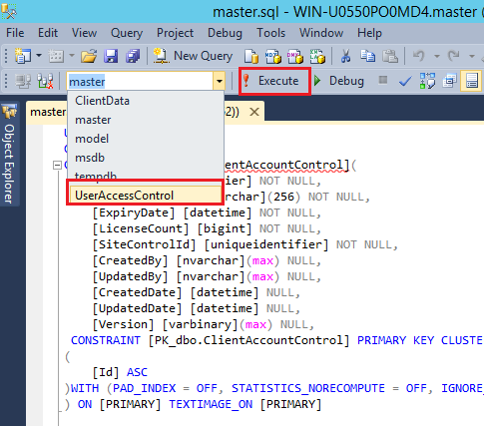
* The process to create UserAccessControl is done

# Create clientdata (tenant) database

* Open your Sql Server then login  
  
* Right click on database and choose New Database…  
  
* Enter ClientData then click OK button as the figure below  
  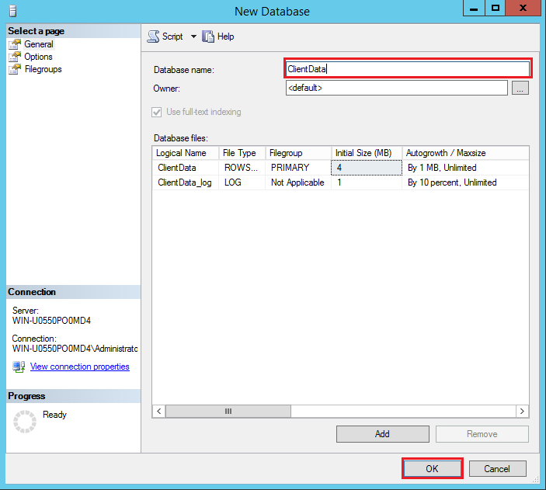
* After database is created, open script to create tables and insert data (Keyboard Shortcuts is Ctrl+O )  
  
* Open tenant.sql file in the package that mentioned above  
  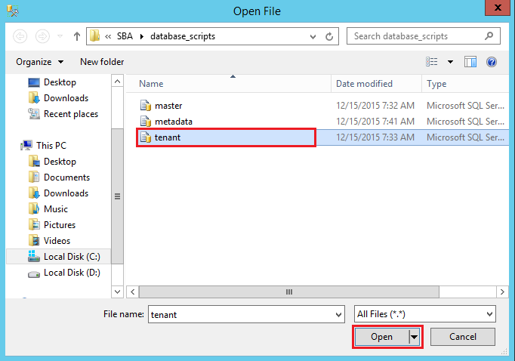
* Choose ClientData database then click Execute (Keyboard Shortcuts is F5)  
  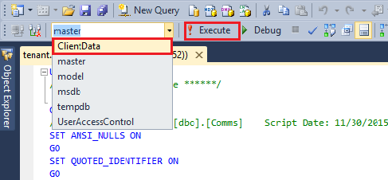
* The process to create UserAccessControl is done

# Create metadata database

* Open your Sql Server then login  
  
* After login success, right click on database and choose New Database…  
  
* Enter Metadata then click OK button as the figure below  
  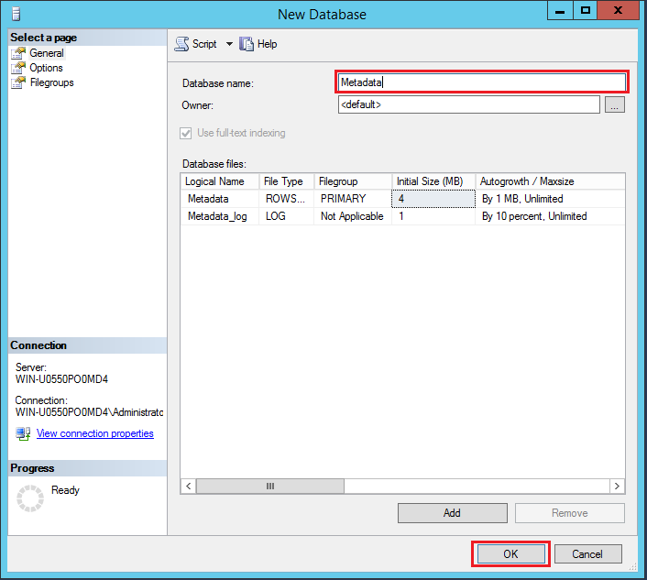
* After database is created, open script to create tables and insert data (Keyboard Shortcuts is Ctrl+O )  
  
* Open metadata.sql file in the package that mentioned above  
  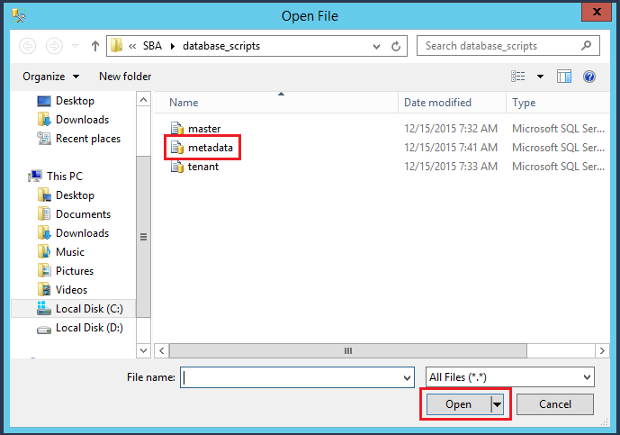
* Choose Metadata database then click Execute (Keyboard Shortcuts is F5)  
  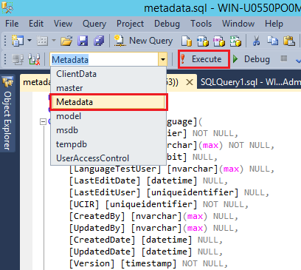
* The process to create Metadata is done

# Create main api from visual studio and configure

## Open project with visual studio

* Go to the source code folder and open solution with visual studio (right click on MainAPISolution.sln and select as below)

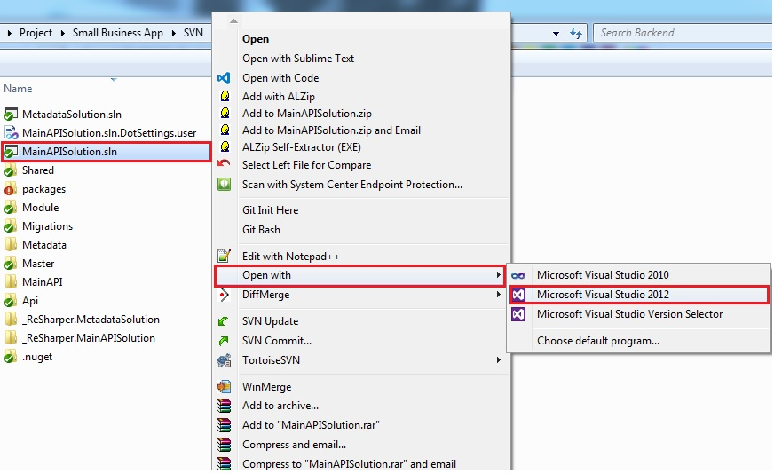

## Create package with visual studio

* Waiting visual studio loaded
* Make sure the solution explorer is showed
* Right click on **SBA.WebApi** choose Publish  
  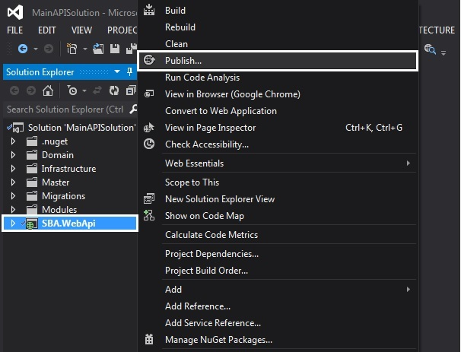
* Create new profile  
  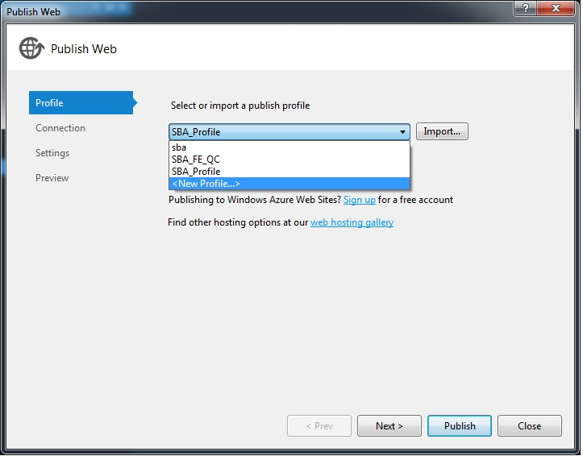
* Enter your profile name then click **Next** button  
  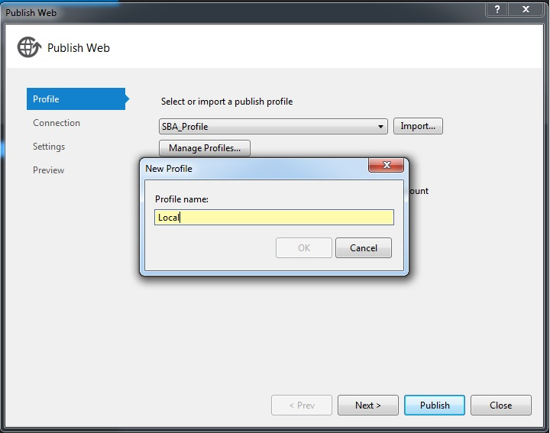
* Configure the connection with **Publish method** is File System and enter the location that contain the api source code then click **Next** button  
  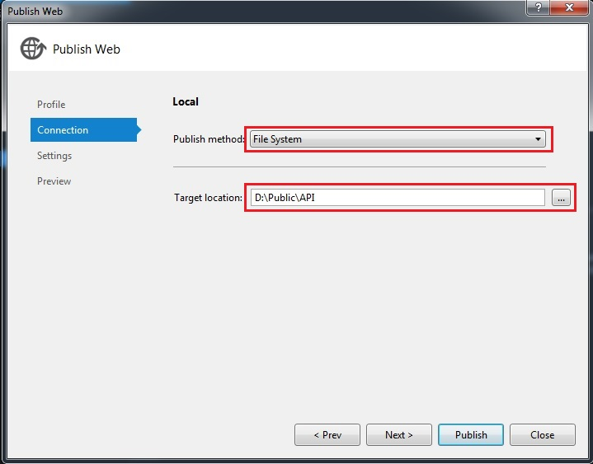
* Configure the Settings such as image below then click **Next** button  
  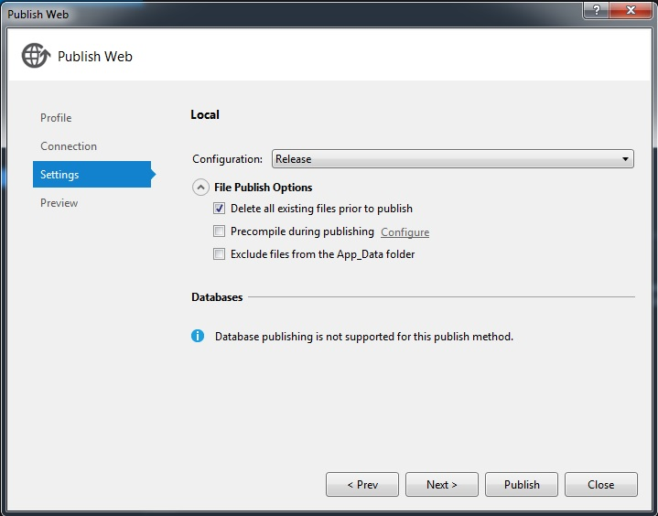
* Preview before publish. Click Publish button to deploy  
  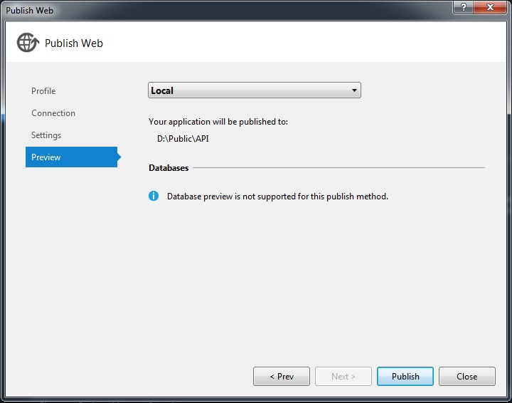
* The api package will be created in the **Target Location** that configure at **connection** session  
  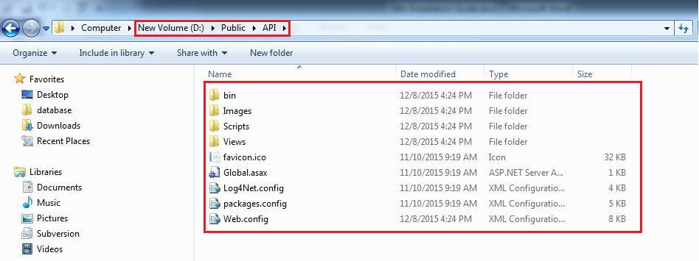

## Configure Api

* Go to the api package that created above  
  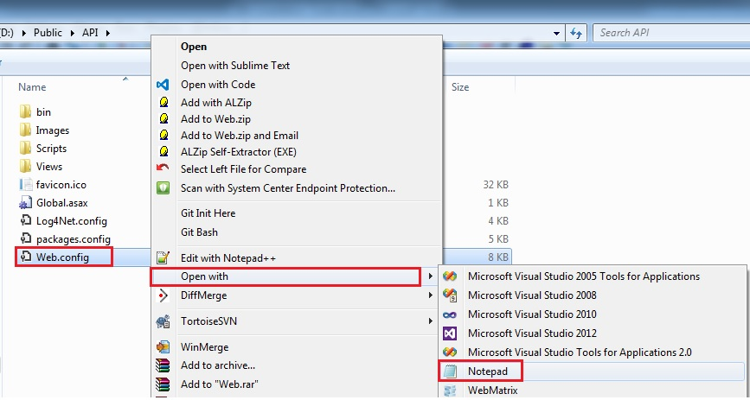
* Right click on Web.config file and open with notepad or notepad++ or any application can read text file  
  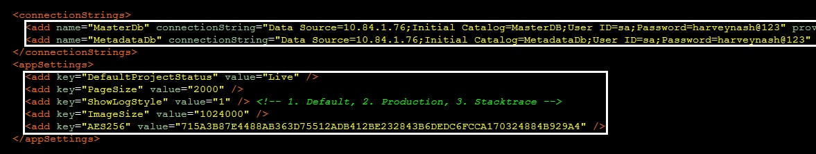
* **MasterDb** is the connection string for Master database, you can change to your connection
* **MetadataDb** is the connection string for Metadata database, you can change to your connection
* **DefaultProjectStatus** is the default project status
* **PageSize** is the default page size
* **ImageSize** is the maximum image’s size

# Create builder api package from visual studio and configure

## Open project with visual studio

* Go to source code folder and open solution with visual studio (right click on MetadataSolution.sln and select as below)  
  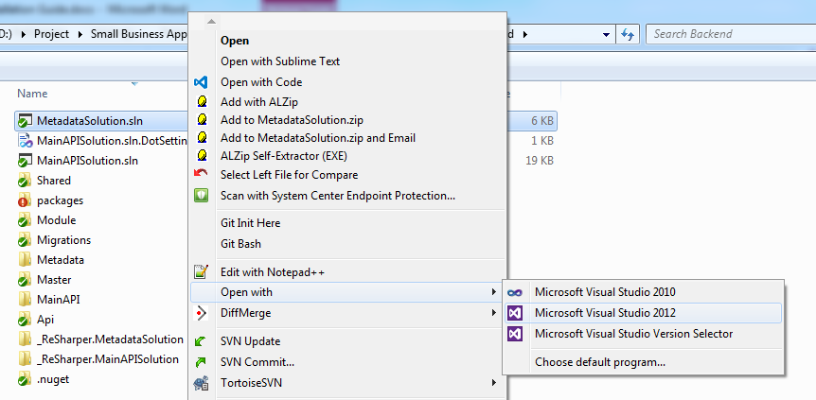

## Create package with visual studio

* Waiting visual studio loaded
* Make sure the solution explorer is showed
* Right click on **SBA.Metadata.WebApi** choose Publish  
  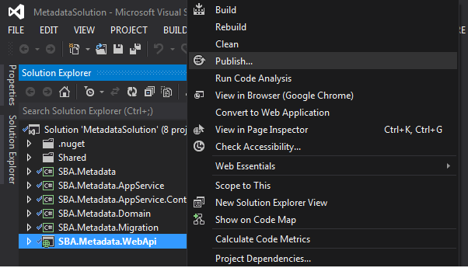
* Create new profile  
  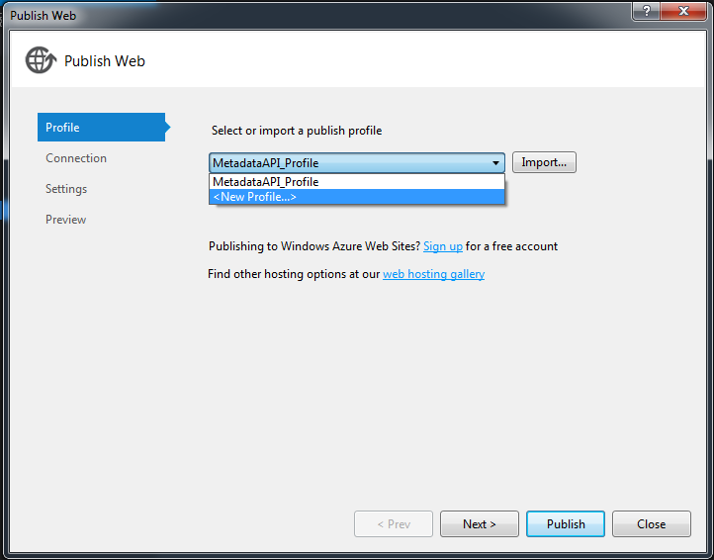
* Enter your profile name then click **Next** button  
  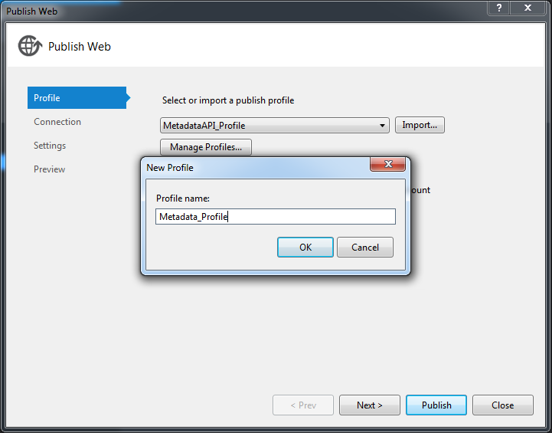
* Configure the connection with **Publish method** is File System and enter the location that contain the api source code then click **Next** button  
  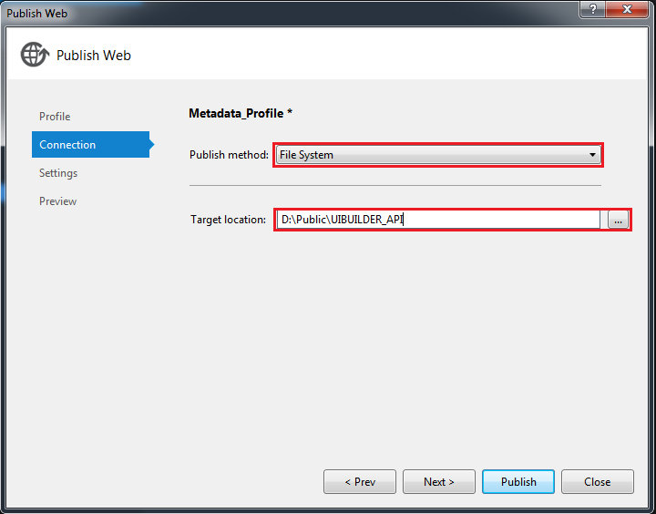
* Configure the Settings such as image below then click **Next** button  
  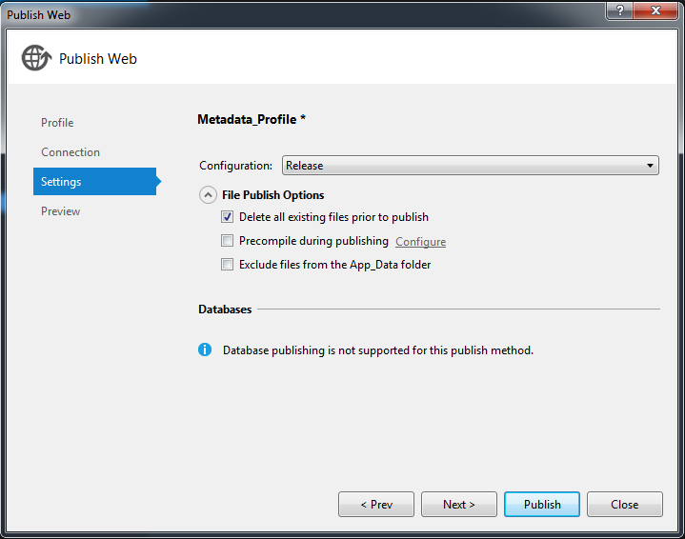
* Preview before publish. Click Publish button to deploy  
  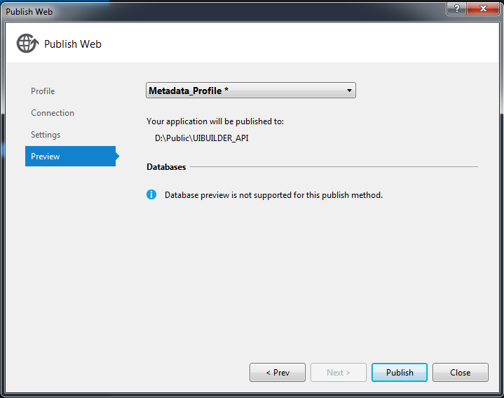
* The api package will be created in the **Target Location** that configure at **connection** step

## Configure Api Uibuider

* Go to the api uibuider package that created above  
  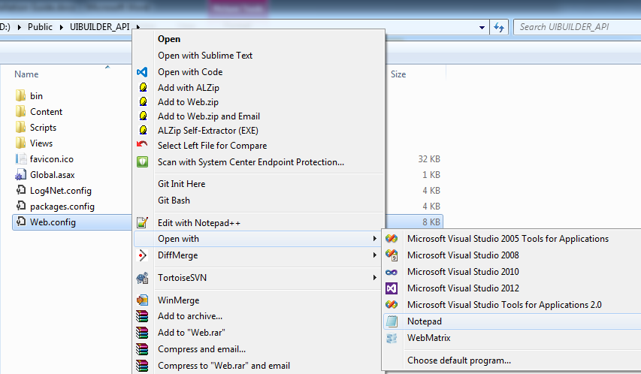
* Right click on Web.config file and open with notepad or notepad++ or any application can read text file  
  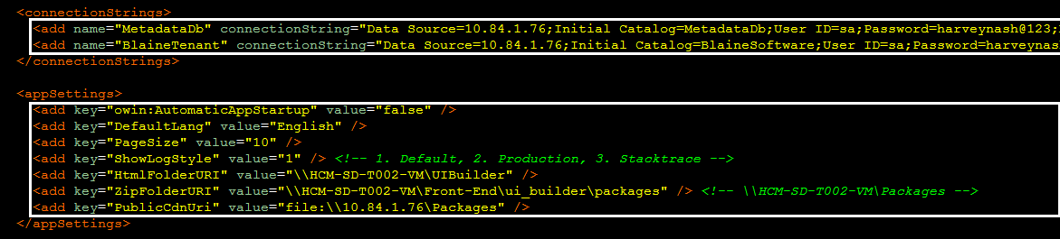
* **BlaineTenant** is the connection string for default tenant database, you can change to your connection
* **MetadataDb** is the connection string for Metadata database, you can change to your connection
* **DefaultLang** is the default language
* **HtmlFolderURI** is the location that contain UiBuilder’s HTML
* **ZipFolderURI** is the zip folder that contain package
* **PublicCdnUri** is the CDN Url
* **PageSize** is the default page size

# Create application pool

* Open IIS (Internet Information Services)
* Right click on Application Pools and choose “Add Application Pool”  
  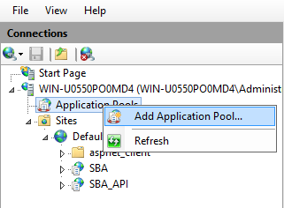
* Enter ClientData and choose options then click OK button as the figure below  
  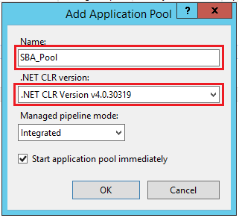
* The Pool is created as the figure below  
  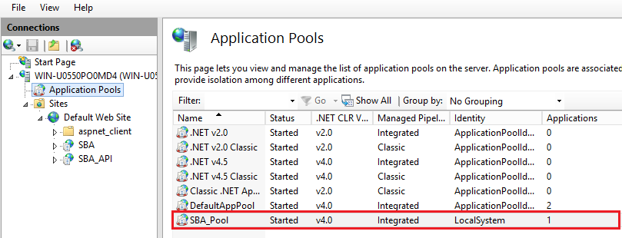

# Host SBA_API on the IIS

* Right click on Default Web Site and choose “Add Application”  
  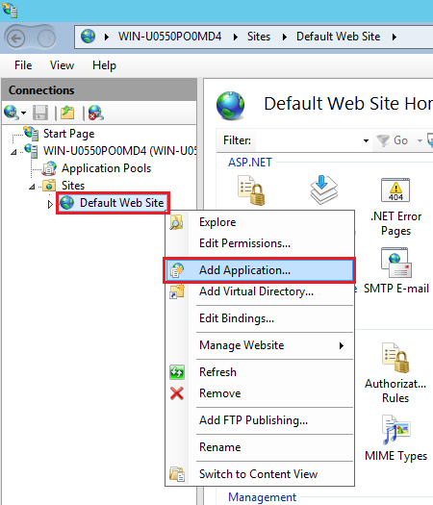
* Enter and select as the figure below  
  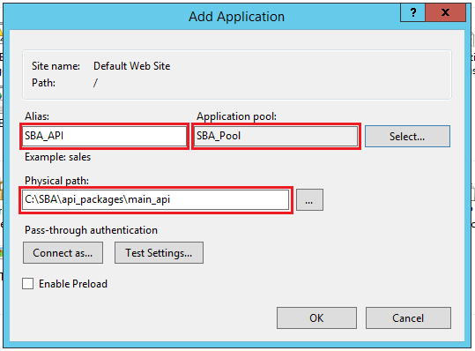
* The result after done  
  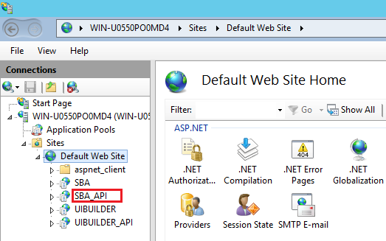

# Host UIBUILDER_API on the IIS

* Right click on Default Web Site and choose “Add Application”  
  
* Enter and select as the figure below  
  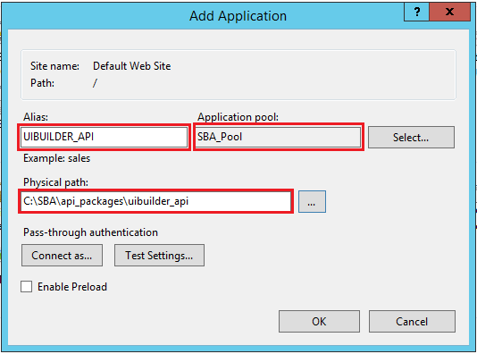
* The result after done  
  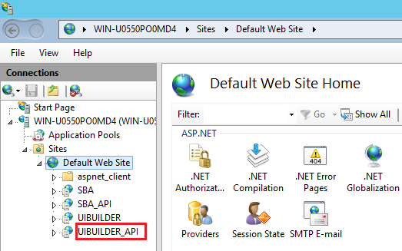

# Host SBA web application on the IIS

* Open IIS (internet information service) then right click on Default Web Site and choose “Add Application”  
  
* Enter and select as the figure below  
  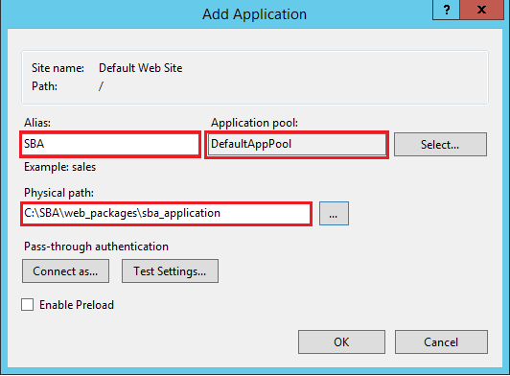
* The result after web application is done  
  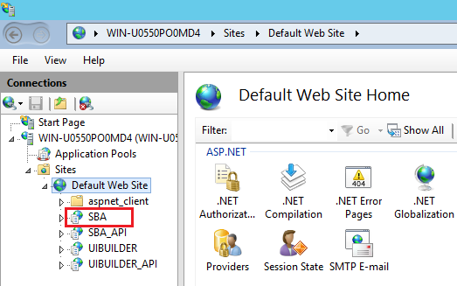

# Host UIBuilder web application on the IIS

* Right click on Default Web Site and choose “Add Application”  
  
* Enter and select as the figure below  
  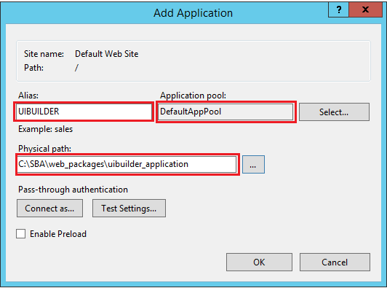
* The result after done  
  